**CCL Assignment 5**

**Name: Rohit Pendse**

**Roll No.- 33358**

**Batch- N11**

**Contact No.-** 8766925932

**Email Id-** [rapendse2002@gmail.com](mailto:rapendse2002@gmail.com)

**ID card-**

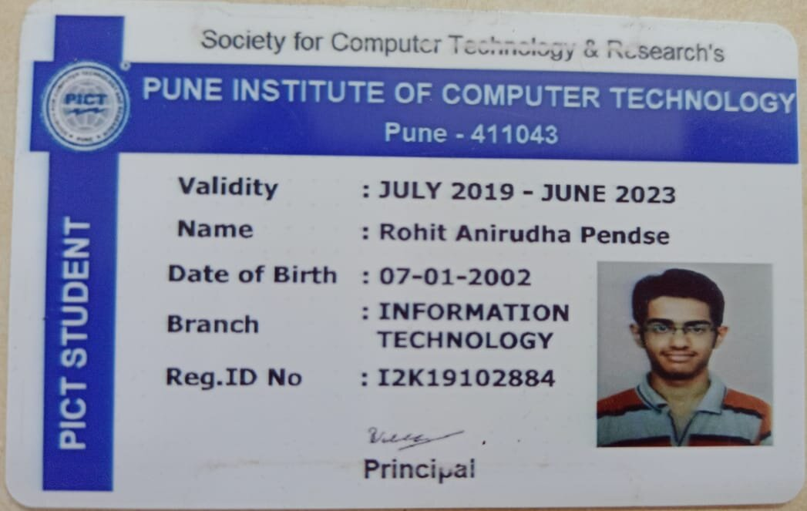

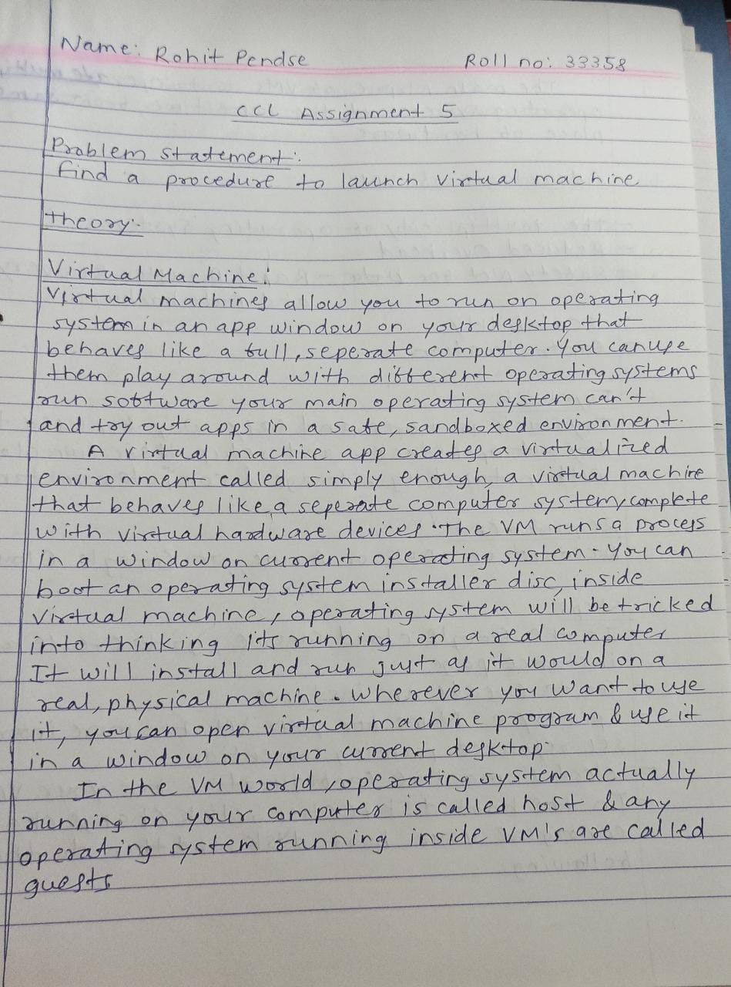

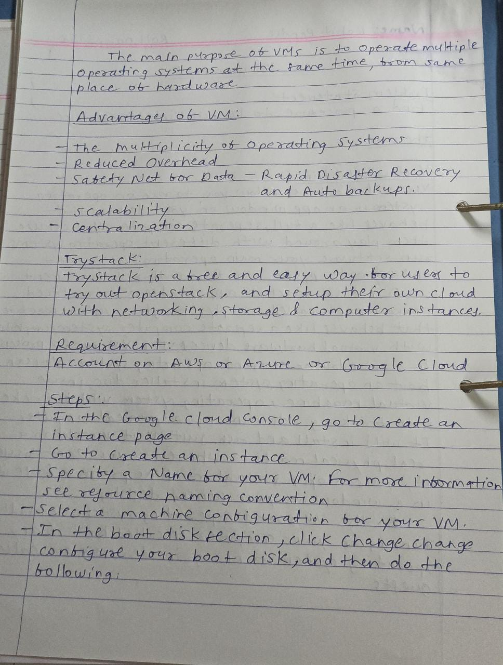

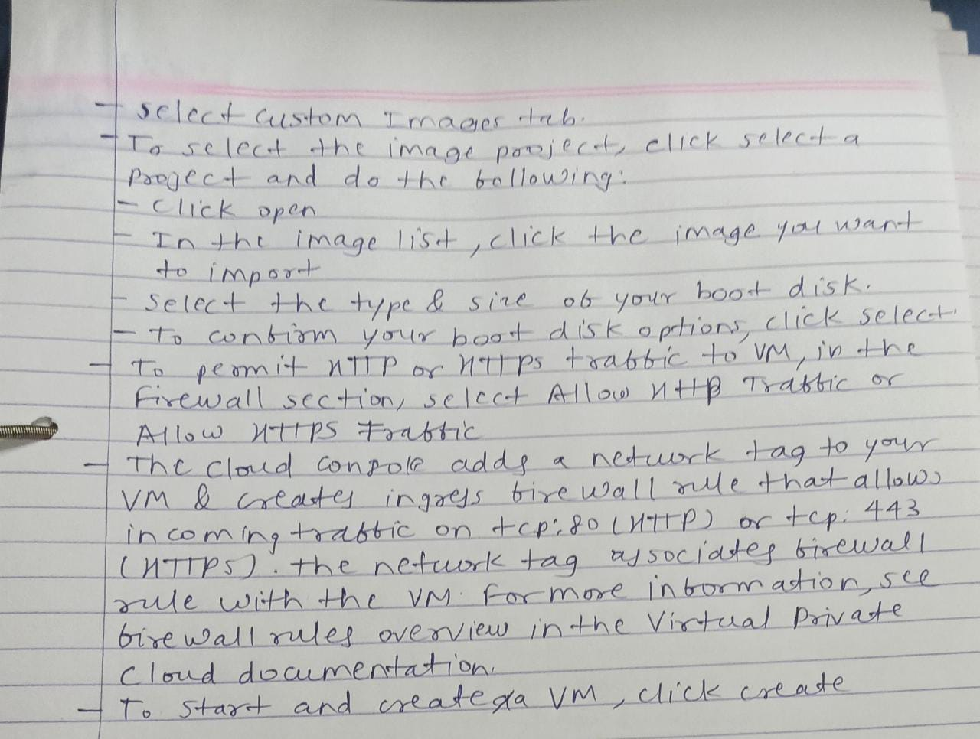

**Output Screenshots:**

1. Create_instance.png:

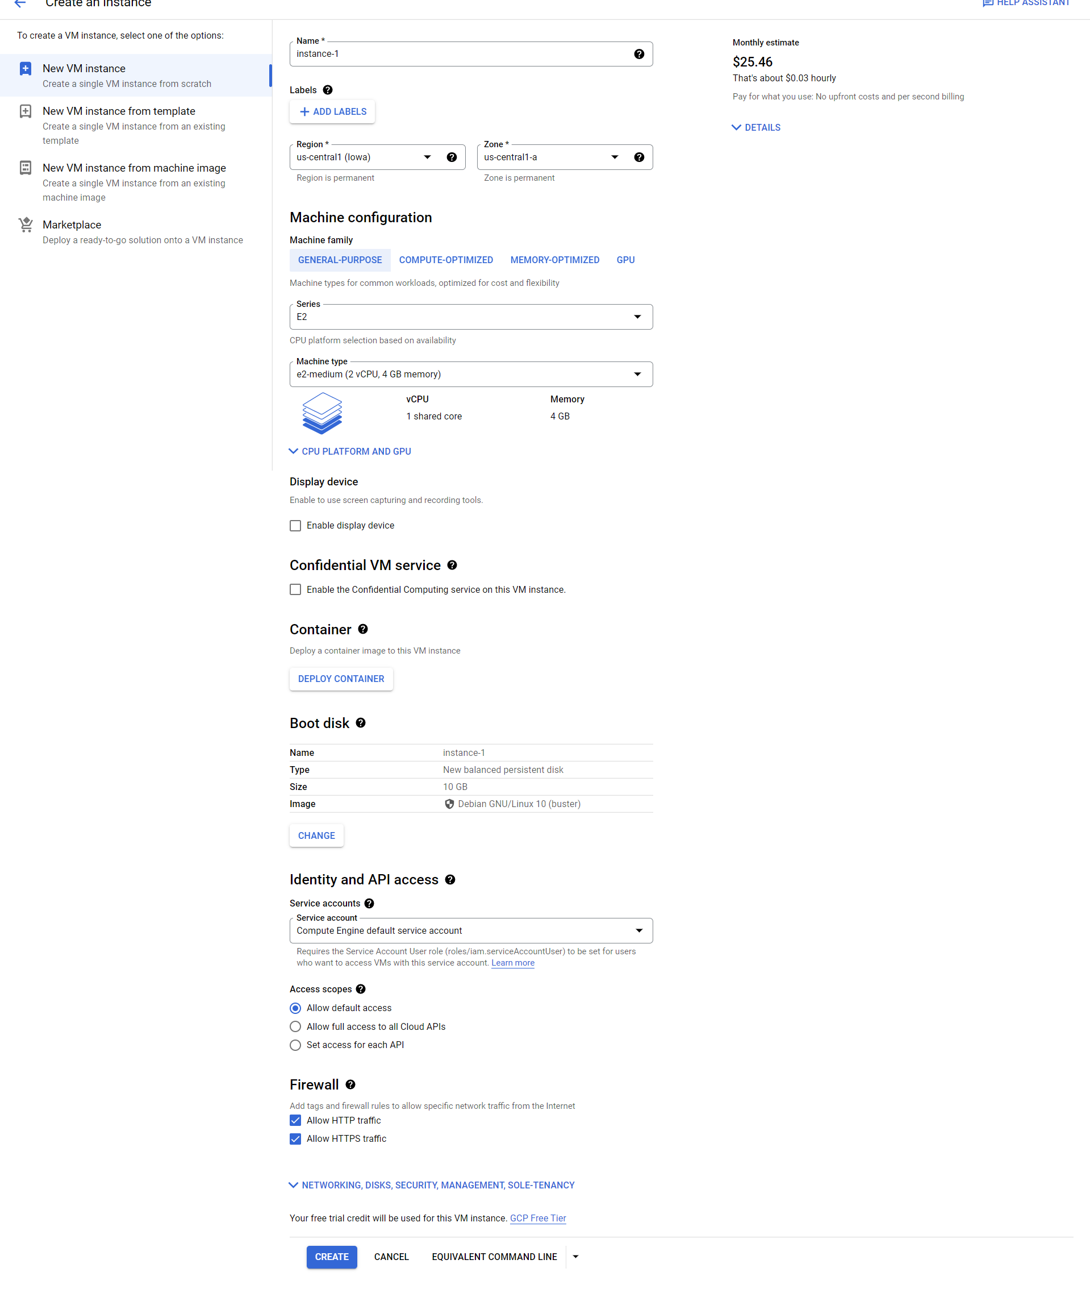

1. Instance_created.png:

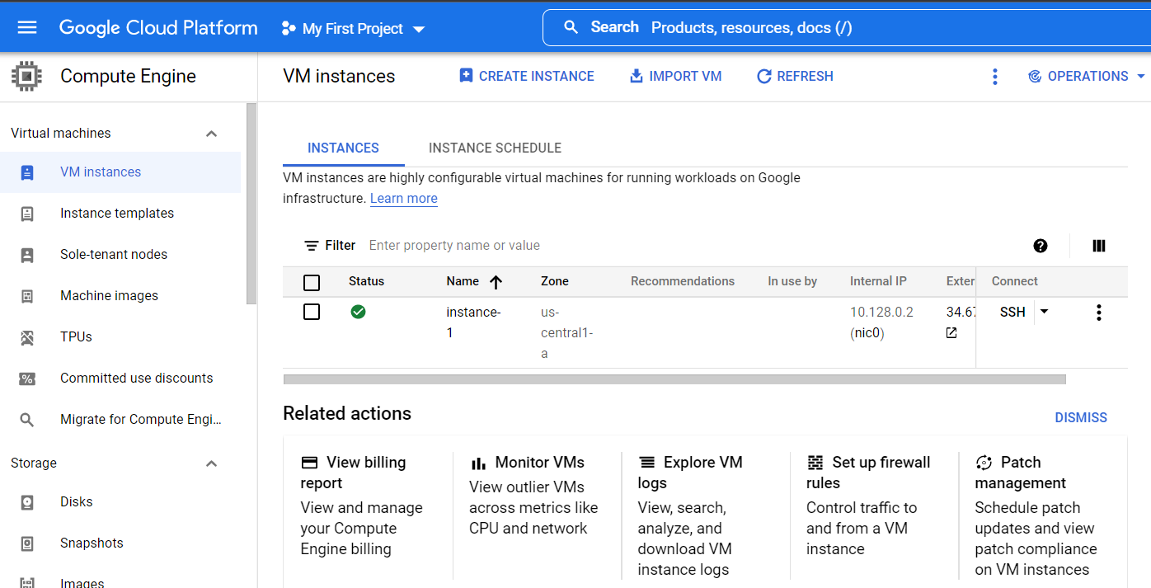

1. Project_info.png:

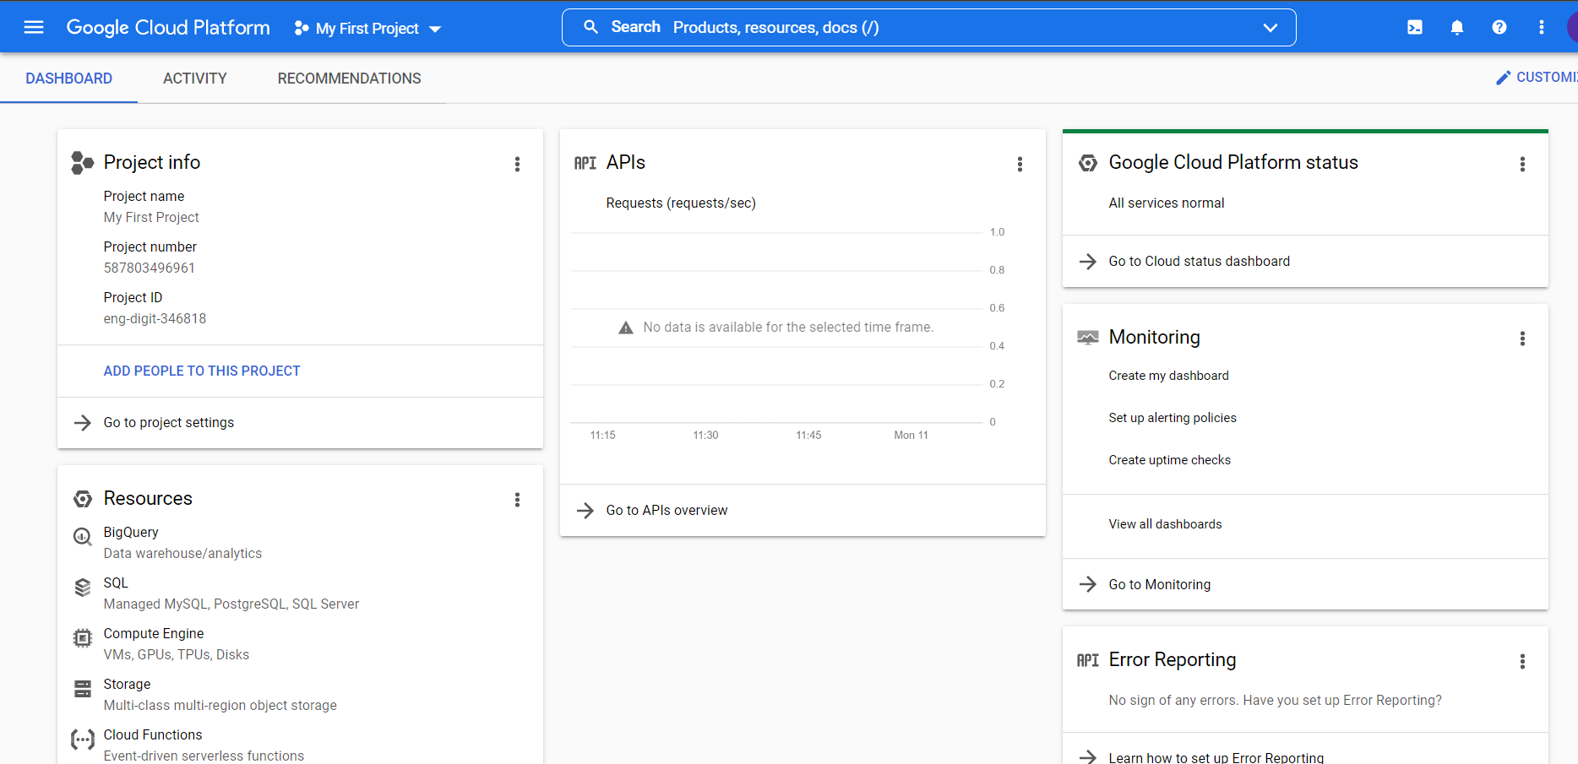

**Conclusion:**

